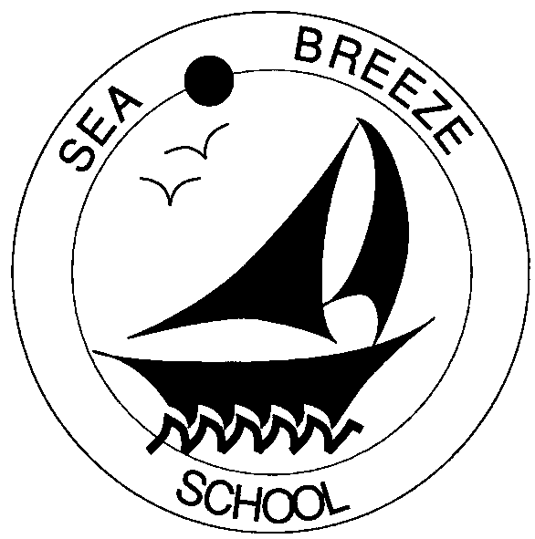
St. Ambrose
Sea Breeze School
900 Edgewater Boulevard
Foster City, CA 94404-3709
Phone: 650-574-5437
Fax: 650-574-5833
Email: seabreezeschool.aol.com

SUNSCREEN AUTHORIZATION & INSTRUCTIONS
PARENTS MUST PROVIDE SUNSCREEN

Child’s Name: ________________________________ Room # _______

I give permission for Sea Breeze staff to apply sunscreen (stick only) to my child. Sunscreen will need to be provided by the parent.

______ Sunscreen Stick

Parent/Guardian Name: ________________________

Signature: ___________________________________ Date: _________________________

Community Care Licensing Title 22 Section 101226(e)(4)

